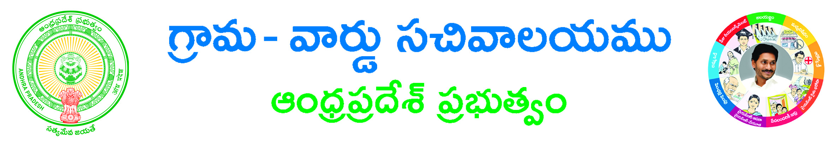

**Circle/Location: ___________________________________**

**Declaration for corrections of Birth and Death entries**

**I _____________________________________ S/O ___________________________________________**

**___________________ Aged about _________________ Years, working as _______________________________**

**(Designation and complete address of the individual of the firm) residing at _____________________________________________________________________________________________**

**(Complete Door No. street and station has to be stated with Telephone number)**

**Declared that**

**I/My ____________________________________ Delivered Male child/ Female child**

**Born/Died in ____________________________ (actual place of event) on ____________________**

**(Date of Event)_______________________________________**

**The Birth /Death certificate Issued on __________________________________________________________**

**The Name/s was wrongly informed by ________________________________ (The person who informs the event has to be stated) please do the following corrections**

|  |  |
| --- | --- |
| **In correct Name** | **To be corrected as** |
|  |  |
|  |  |
|  |  |

STATION: ___________

**Date: _________________ SIGNATURE OF THE DECLARANT**

**(Declarants Name in Capital Letters)**

**I Know Sri/Smt _________________________________________________________________________**

**S/O W/O______________________________________________________________________________**

**as a resident of _______________________________________________________________________**

**The signature of the Declarant is taken in my presence and contents mentioned by the Declarant are true and correct to the best of my knowledge and belief.**

**1. 2.**

**GAZETTED OFFICER GAZETTED OFFICER**

**Sign &Seal & Sign &Seal &**

**(Name of the officer) (Name of the officer)**

**CSC Transaction No. CSC Transaction No.**

**The following Documents should be produced by the Declarant for name corrections in Birth/Death registers.**

**1. Declaration by the nearest relative (parents/Childs/spouse) in case of death and either father or mother in case of live Birth.**

**2. The declaration stated should be true and correct by two Gazatted officers (names of Gazatted officers are to be written in Capitals)**

**3. Notary affidavit on (Rs. 10/. Non judicial Stamped paper).**

**4. The original Birth/ Death certificates already taken are to be returned.**

**5. Documentary evidences like educational certificates , election ID card, Ration card, passport, Driving Licenses, Marriage certificate, LIC policies, caste certificates, property papers, etc (evidence to be submitted before birth of the child or Death of Deceased )**

**6. Consent letter from concerned Hospital regarding the correction to the effect.**

**7. Other child certificates if any.**

**8. In case of Medico Legal death a) Post mortem report b) Form – 2 by concerned police station**

**9. Any other support Documents if any please specify.**